Learning Journal Unit 5

Godfrey Ouma
University of the People
MATH 1201: College Algebra
Yousef Ajeeb
12 October 12, 2023

Learning Journal Unit 5
- Reflect on the concept of exponential and logarithm functions. What concepts (only the names) did you need to accommodate these new concepts in your mind?
The concept I use to understand the concept of logarithm function is the inverse function to exponentiation. For instance, ${10}^{2}=100$ is an exponential function that can be converted into logarithm function as $\log_{10}100=2$. Abramson (2021) notes that for any real number an exponential function is a function with the form $y={ab}^{x}$, while for any real number a logarithmic function is a function with the form $\log_{b}x=y$, which equivalent to $x=b^{y}$. Since the logarithmic and exponential functions switch the and values, another concepts I needed to accommodate the two functions is that domain and range of the exponential function are interchanged for the logarithmic function. Therefore, the domain of the logarithm function with base b is $(0,∞)$, while the range of the logarithm function with base b is $(-∞,∞)$ (Abramson, 2021).
- What are the simplest exponential and logarithmic functions with base b ≠ 1 you can imagine?
The simplest exponential function is a function with the form ${f\left(x\right)=b}^{x}$, while the simplest logarithmic function is a function with the form ${g\left(x\right)=log}_{b}x$, where b is the base and $b≠1$.
- In your day to day, is there any occurring fact that can be interpreted as exponential or logarithmic functions?
Exponential function can be applied in the school to investigate the exponential growth of the rate of the spread of a contagious disease, such as the flu, among the student population. In such a scenario, as more students become infected, they can transmit the illness to others, leading to an exponential increase in the number of cases. This scenario can be modelled using the exponential function $P\left(t\right)=Pe^{rt}$, where:
- P(t) represents the number of infected students at time,
- $P_{0}$ is the initial number of infected students at $t=0$,
- e is Euler's number, approximately equal to 2.71828,
- r is the growth rate of the disease, indicating how fast the infection spreads, let us say 0.25 per day, and
- t is the time (in days).
The exponential function graph is shown below.
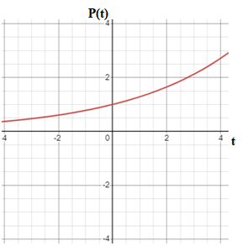
From the graph above, at t=0, only one student was infected with the flu. However, the infected student come to school, interact with their classmates, and unintentionally spread the virus. With time, each infected student can potentially infect several others, who, in turn, can infect more students. This process continues, and the number of infected students rapidly multiplies. Exponential growth occurs because each infected person can create a chain reaction, causing the number of cases to skyrocket. Within a short period, a significant portion of the school population may become infected.
On the other hand, a common example of logarithmic growth in a school setting is the concept of diminishing returns in studying. As students spend more time studying for a particular subject, their rate of learning or improvement tends to decrease. A logarithmic function that models this situation can be written as: $S\left(t\right)=A.In(t+1)$, where:
- S(t) represents the student's level of understanding or mastery of the subject at time t.
- A is the maximum achievable level of understanding.
- t is the time spent studying.
The graph representing this situation is as follows.
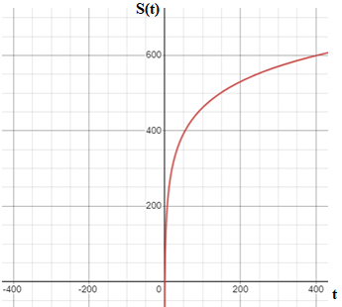
From the graph above, it is evident that as t (time spent studying) increases, the natural logarithm term $In(t+1)$ results in diminishing returns. This reflects the idea that for each additional unit of time spent studying, the increase in understanding becomes progressively smaller. It's a common phenomenon in learning where initial efforts yield substantial progress, but additional efforts provide smaller increments in knowledge. Therefore, the graph displays logarithmic growth, showing rapid progress at the beginning (steep slope) that gradually levels off as time increases.
- What strategy are you using to get the graph of exponential or logarithmic functions?
Given a logarithmic function with the form ${g\left(x\right)=log}_{b}x$, the strategy used to graph the function will be as follows:
- Step 1: Draw and label the vertical asymptote, x=0.
- Step 2: Plot the x-intercept, (1,0).
- Step 3: Plot the key point (b,1).
- Step 4: Draw a smooth curve through the points.
- Step 5: State the domain, $(0,∞)$ the range, $(-∞, ∞)$, and the vertical asymptote, x=0.
Given an exponential function with the form $f(x)=b^{x}$, the strategy used to graph the function will be as follows:
- Step 1: Create a table of points.
- Step 2: Plot at least point from the table, including the y-intercept (0,1).
- Step 3: Draw a smooth curve through the points.
- Step 4: State the domain, $\left(-∞, ∞\right),$ the range, $(0,∞)$, and the horizontal asymptote, y=0.

Reference
Abramson, J. (2021). Algebra and trigonometry (2nd ed.). OpenStax, TX: Rice University. Retrieved from https://openstax.org/details/books/algebra-and-trigonometry-2e

